4.4. Temporal Dynamics, Oxidative-to-Optical Delay, and Optical Compression
The temporal outputs defined in Section 3.11 were evaluated for both admissible ROS-to-UPE transfer structures to determine whether structural uncertainty affected only emission magnitude or also altered the timing of the optical response. Onset time was defined as the first time at which intrinsic UPE reached 10% of the maximum for the corresponding condition, while time to peak was the time of maximum intrinsic emission. The oxidative-to-optical delay was calculated relative to the maximum of the emission-relevant oxidative pool, which occurred at 24.0 h in the shared upstream biological trajectory.
Under the PMA-constrained high-gain mapping, temporal behavior was largely preserved across disease conditions. The 10%-of-peak onset occurred at 6.4 h for healthy and severe COVID-19 conditions and at 6.6 h for sepsis, while all three conditions reached maximum intrinsic UPE at 27.6 h. Because the emission-relevant oxidative pool peaked at 24.0 h, the corresponding oxidative-to-optical delay was 3.6 h for all three conditions (Table 3C; Figure 5A-B). Thus, in the high-gain structure, increasing oxidative amplitude primarily scaled the magnitude of the optical response without materially changing its characteristic timing.
The disease-saturating mapping produced a different temporal pattern. The healthy response reached 10% of its own peak at 5.4 h and peaked at 27.8 h, whereas severe COVID-19 and sepsis reached the same relative onset criterion substantially earlier, at 2.2 and 1.8 h, respectively. Their peak emission occurred later, at 29.6 h for COVID-19 and 30.2 h for sepsis. The resulting oxidative-to-optical delays increased from 3.8 h in the healthy condition to 5.6 h for COVID-19 and 6.2 h for sepsis (Table 3C; Figure 5A-B). This combination of earlier relative onset but later peak emission is consistent with rapid entry into a nonlinear saturated regime followed by a prolonged approach to the bounded maximum response.
The two structures also differed sharply in their optical compression behavior. Using the compression metric defined in Section 3.11, the high-gain structure produced values greater than unity for both disease conditions: 4.69 for severe COVID-19 and 6.42 for sepsis. These values indicate amplification, because the peak-UPE fold changes of 42.21 and 89.02 exceeded the corresponding clinical oxidative folds of 9.01 and 13.86. In contrast, the disease-saturating structure produced compression ratios of 0.160 for COVID-19 and 0.105 for sepsis, reflecting the transformation of the same oxidative inputs into peak-UPE fold changes of only 1.445 and 1.450 (Table 3C; Figure 5C).
Taken together, the temporal analysis shows that uncertainty in the ROS-to-UPE transfer structure affects more than predicted emission amplitude. The high-gain mapping preserves a nearly common timing profile while amplifying disease-associated oxidative differences, whereas the saturating mapping compresses peak magnitude, advances the relative onset of the disease response, and lengthens the delay between peak emission-relevant oxidation and peak photon emission. These timing differences provide additional experimentally testable observables that could help discriminate between competing transfer structures in paired ROS-UPE measurements.
Table 3C. Temporal metrics and optical compression under the two structural ROS-to-UPE mappings.
Mapping | Condition | Onset  (h) | Time to peak  (h) | Δt Re→UPE  (h) | Peak UPE  fold | ROS  fold | Compression  ratio
PMA-constrained high-gain | Healthy | 6.4 | 27.6 | 3.6 | 1.000 | 1.000 | —
PMA-constrained high-gain | COVID-19 | 6.4 | 27.6 | 3.6 | 42.206 | 9.007 | 4.686
PMA-constrained high-gain | Sepsis | 6.6 | 27.6 | 3.6 | 89.020 | 13.856 | 6.425
Disease-saturating | Healthy | 5.4 | 27.8 | 3.8 | 1.000 | 1.000 | —
Disease-saturating | COVID-19 | 2.2 | 29.6 | 5.6 | 1.445 | 9.007 | 0.160
Disease-saturating | Sepsis | 1.8 | 30.2 | 6.2 | 1.450 | 13.856 | 0.105
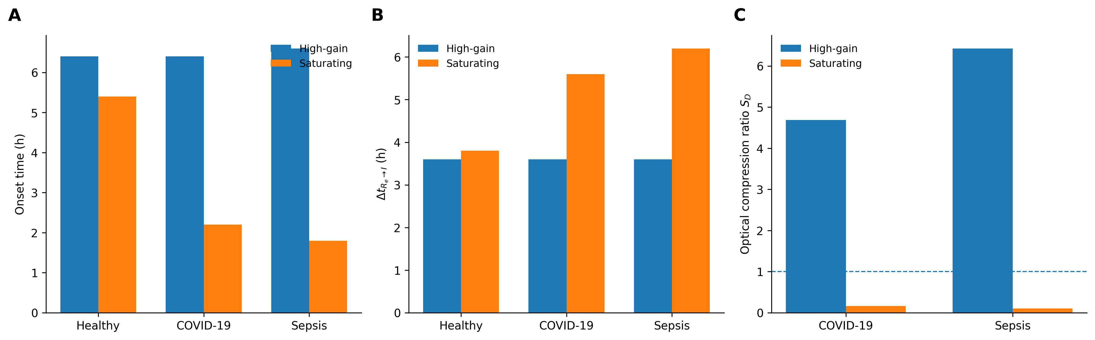
Figure 5. Temporal consequences of alternative ROS-to-UPE transfer structures. (A) Relative onset time, defined as the first time intrinsic UPE reached 10% of the maximum for each condition. (B) Oxidative-to-optical delay from the peak of the emission-relevant oxidative pool to peak intrinsic UPE. (C) Optical compression ratio for severe COVID-19 and sepsis. Values above unity indicate amplification of the clinical oxidative fold, whereas values below unity indicate compression. The high-gain mapping largely preserves temporal timing while amplifying disease differences; the saturating mapping advances relative onset, delays peak emission, and strongly compresses disease-associated magnitude.

